INFOSYS SPRINGBOARD VIRTUAL INTERNSHIP 7.0
Completion Report

Internship Details: Team : TeamD Batch : batch-01 Group : Group 1
Start Date: 29th June 2026 Internship Duration: 8 Weeks

Team Members:
- Uppala Bhavya Sri
- V. Charita Sree
- Velpuri Sai Rohitha
- Venkata Puneeth Kothapalli
- Yuvasree P

PROJECT TITLE
Supply Chain Visibility System with Optimization Analytics Group 1

Project Objective
- The objective of this project is to develop an interactive Supply Chain Analytics Dashboard using Microsoft Power BI to provide comprehensive visibility into sales, orders, customers, products, delivery operations, geographic markets, costs, and profitability.
- Modern supply chain systems generate large volumes of transactional data through customer orders, product purchases, shipping activities, delivery operations, market transactions, and financial activities. However, raw transactional data is difficult to interpret directly and may not provide an immediate understanding of business performance. Therefore, this project focuses on transforming the available supply chain data into meaningful visual insights that can support effective analysis and decision-making.
- The project uses the DataCoSupplyChainDataset, which
contains approximately 80,519 records and multiple attributes related to orders, customers, products, sales, shipping, delivery, geography, discounts, and profit. The dataset provides sufficient information to analyze the business from several perspectives.
- The major objectives of the project are:

- Data Preparation: Prepare and transform the raw supply chain dataset using Power Query so that it can be effectively used for analysis and reporting.
- Sales Analysis: Analyze total sales, orders, profit, sales trends, customer segments, payment types, and order status.
- Delivery Performance Analysis: Evaluate on-time delivery, late delivery, average delivery delay, shipping modes, actual shipping days, and scheduled shipping days.
- Customer Analysis: Understand customer segments, customer contribution, average items per order, and average profit per order.
- Product Analysis: Identify top-performing products and categories based on quantity and sales contribution.
- Geographic Analysis: Analyze sales performance across countries, regions, and markets.
- Cost and Profitability Analysis: Examine discounts, sales, profit ratio, and category-level profitability.
- Dashboard Development: Develop interactive Power BI dashboards using KPI cards, charts, decomposition trees, scatter plots, and other suitable visuals.
- Business Insight Generation: Convert analytical findings into meaningful insights that can support supply chain planning and business decision-making.

Project Description in Detail

Project Overview
    - The project focuses on developing a Business Intelligence solution for Supply Chain Analytics using Microsoft Power BI. It transforms raw transactional information into interactive and meaningful visual reports.
    - The project uses the DataCoSupplyChainDataset, which contains approximately 80,519 records related to orders, customers, products, sales, shipping, delivery, geography, discounts, and profitability.
    - The dashboard is designed to provide visibility into different areas of business performance rather than focusing on a single metric. This allows users to analyze the supply chain from multiple perspectives.
    - The final dashboard contains six analytical pages: Sales Performance Overview, Supply Chain Delivery & Operations Performance, Customer & Business Insights, Product & Category Performance, Geographic & Market Performance, and Supply Chain Cost & Profitability Analysis.
    - Each page contains relevant KPIs and visualizations that help users understand business performance quickly. The interactive design also makes it easier to compare different categories, regions, customers, products, and operational factors.

Project Approach
The project was completed through a systematic nine-step workflow. Each stage was carried out sequentially, beginning with understanding the project requirements and ending with sharing the completed results. The workflow helped ensure that the data was properly collected, understood, prepared, analyzed, organized, and communicated effectively.

Problem Understanding
The first step was to understand the overall project requirements and identify the problem that needed to be addressed. The team studied the objectives, expected outcomes, and major areas that required analysis.
The project required converting large amounts of raw business information into meaningful and understandable results. Important areas such as sales, orders, customers, products, delivery activities, geographical information, costs, discounts, and profitability were considered during this stage.
This step helped the team clearly define the scope of the work, identify the major requirements, and establish a proper direction for the remaining stages of the project.

Data Collection
The second step involved collecting the required data from the selected source. The DataCoSupplyChainDataset was used as the

primary dataset for the project because it contained information covering several business and supply chain activities.
The dataset included details related to orders, customers, products, sales, quantities, shipping, delivery, geographical areas, discounts, and profit. These different attributes provided sufficient information for carrying out detailed analysis.
The collected data was initially reviewed to ensure that the required information was available and suitable for the project objectives. This stage provided the basic data foundation for the subsequent processing and analysis activities.

Data Understanding
After collecting the data, the third step was to understand the structure and meaning of the available information. The dataset was examined carefully to identify its columns, records, data types, and business-related attributes.
The team studied the meaning and purpose of important fields and identified numerical, categorical, date-related, and other relevant attributes. Relationships between different business attributes were also considered to understand how the information could be used during analysis.
This stage was particularly important because working with a large dataset requires a clear understanding of what each field represents. Proper data understanding helped the team select relevant information and avoid unnecessary or incorrect usage of data.

Data Connection
The fourth step involved connecting the collected dataset to the analytical environment. The dataset was imported and the available fields were reviewed after the connection was established.
The team verified whether the required columns were available and whether the data had been loaded correctly. Data types such as text, numerical values, and dates were checked to ensure that they were recognized appropriately.
This step created the connection required for further data preparation and analysis. It also helped identify any initial issues with field recognition or data loading before proceeding to the next stage.

Data Preprocessing
The fifth step focused on preparing the raw data for accurate and consistent analysis. The dataset was examined for missing values, duplicate records, inconsistent formats, incorrect data types, and other data-quality issues.
Necessary transformations were performed on the relevant fields. Text values, numerical fields, dates, and other attributes were reviewed and standardized wherever required.
Data preprocessing was an essential stage because inaccurate or inconsistent data can directly affect analytical results. By improving

the quality and consistency of the dataset, the team established a reliable foundation for further calculations and analysis.

Data Analysis
The sixth step involved analyzing the prepared data to identify meaningful patterns, trends, relationships, and performance indicators. The analysis was performed based on the objectives identified during the problem-understanding stage.
Different business areas were examined, including sales, orders,

customers, | products, delivery | performance, geographical
distribution, | discounts, costs, | and profitability. Relevant
calculations | and measures were | developed to summarize the
information.
The results were then reviewed to identify important observations and relationships within the data. This stage helped transform the prepared dataset into meaningful analytical information that could be interpreted from a business perspective.

Data Modeling
The seventh step involved organizing the prepared data and analytical calculations into a structured model. The relationships between different fields and categories were examined to ensure that the data could be analyzed consistently.
Calculated measures and important metrics were organized systematically. The structure of the data was reviewed to ensure

that calculations were accurate and that different analytical requirements could be handled efficiently.
Proper data modeling helped maintain consistency, reduce calculation errors, and improve the reliability of the analytical process. It also provided a structured foundation for presenting the results in the following stages.

Data Visualization
The eighth step involved converting the analyzed information into a clear and understandable visual form. Appropriate visualization techniques were selected based on the type of information being presented.
Different types of charts, graphs, tables, KPI representations, and other visual methods were considered to communicate numerical values, comparisons, trends, relationships, and distributions effectively.
The main objective of this stage was to make complex information easier to understand. Proper visual representation allowed important patterns and differences to be identified quickly and improved the overall communication of the analytical results.

Share and Publish
The final step involved organizing, reviewing, and sharing the completed project outcomes. The analytical results, important observations, documentation, and supporting materials were reviewed to ensure completeness and accuracy.
The completed work was organized according to the project requirements and prepared for final submission and presentation. Necessary documentation was also maintained to explain the methodology, technologies used, challenges encountered, and learning outcomes.
Finally, the completed project was shared with the relevant team members and stakeholders. This stage marked the completion of the project workflow and ensured that the final results were properly communicated and available for review and future reference.

Technology Used
The project was developed using modern Business Intelligence tools and technologies to ensure accurate data processing, visualization, and reporting.

Technology | Purpose
Microsoft Power BI | Dashboard development, interactive data visualization, and business reporting
Microsoft Power Query | Data cleaning, preprocessing, transformation, and data preparation
DAX (Data  Analysis Expressions) | Creating KPIs, calculated measures, and business metrics
Microsoft Excel | Source dataset preparation, storage, and initial data handling
Data  Visualization Techniques | Presenting insights through charts, maps, tables, KPI cards, and slicers
Microsoft Teams | Team communication, project discussions, meeting coordination, and collaboration
GitHub | Version control, project code/documentation management, and collaboration
GitLab | Source code management, project repository management, and team collaboration

These technologies collectively enabled efficient data analysis, interactive business intelligence, version control, and collaborative project development, resulting in an effective and user-friendly analytics solution.

Insights from the Dashboard
    - Sales Performance Overview: The Sales Performance Overview page provides a clear summary of Total Orders, Total Sales, and Total Profit. It also analyzes yearly sales trends, customer segment contribution, payment types, and order status, helping users understand the overall business performance.
    - Supply Chain Delivery & Operations: This page focuses on shipping and delivery efficiency. It displays an On-Time Delivery Rate of 17.83%, Late Delivery Rate of 54.82%, and Average Delivery Delay of 0.57, along with comparisons of shipping modes, delivery status, and regional delivery performance.
    - Customer & Product Performance: The Customer & Business Insights page provides information about 20,652 customers, an average of 5.84 items per order, and an average profit per order of ₹21.98. The Product & Category Performance page further identifies top products and categories while analyzing discount rates and their relationship with profitability.

    - Geographic & Market Performance: The Geographic & Market Performance page compares sales across different markets, countries, and regions. Among the displayed markets, Europe contributes approximately ₹10.87M, representing around 29.5%, helping identify major geographic contributors to overall business performance.
    - Cost & Profitability Analysis: The Supply Chain Cost & Profitability page analyzes total discount amount, profit ratio, yearly sales trends, category sales, and regional sales. Overall, the six dashboard pages provide an interactive and consolidated view of sales, customers, products, delivery, geography, costs, and profitability, supporting better business analysis and data-driven decision-making.

Real-World Impact for Media and Public Communication

he dashboard converts large and complex supply chain data into simple visual information, making business performance easier to understand and communicate.

It provides a centralized reporting platform where important KPIs and performance indicators can be viewed without manually analyzing multiple datasets or spreadsheets.
 Interactive charts allow users to compare sales, customers, products, delivery performance, and geographic markets, helping them communicate important findings more effectively.

The dashboard can reduce manual reporting effort and improve the speed at which business information is prepared and shared with stakeholders.

Overall, the project demonstrates how Business Intelligence and data visualization can improve communication, increase data visibility, and support more informed and data-driven decisions..

TIMELINE OVERVIEW

WEEK | ACTIVITIES PLANNED | ACTIVITIES COMPLETED
Week 1 – Project Initiation & Requirement Understanding | Understand the internship objectives, project requirements, problem statement, expected outcomes, and overall scope of the project. Identify the major business areas and determine the type of data required for the analysis.. | The project requirements and objectives were studied in detail. The team understood the overall problem, identified the major areas of analysis such as sales, orders, customers, products, delivery, geography, costs, and profitability, and discussed the expected project outcomes. The roles and responsibilities within the team were also understood and the overall project  workflow was planned.
Week 2 – Data Collection & Dataset Understanding | Collect the required dataset and examine its structure, records, columns, data types, and business attributes. Identify relevant fields and understand the meaning of the available information. | The DataCoSupplyChainDataset was collected and examined. The dataset structure, records, columns, and different business attributes were studied. Important fields related to orders, customers, products, sales, quantity,  shipping, delivery,

geographical areas, discounts, and profit were identified. The team developed a basic understanding of how the different fields represented
business activities.
Week 3 – Data Connection & Initial Data Preparation3 | Connect the collected dataset to the analytical environment and verify that the required fields are available. Check data types, field recognition, and the overall quality of the imported data.. | The dataset was successfully connected to the working environment. The available columns were reviewed and the data types of important fields were checked. Date, numerical, text, and categorical fields were examined to identify possible issues. Initial observations were recorded and the data preparation  requirements were identified
Week 4 – Data Cleaning & Preprocessing | Clean and transform the dataset to make it suitable for reliable analysis. Handle  missing values,  duplicate records, inconsistent formats, incorrect data types, and other data-quality issues. | The dataset was cleaned and prepared using data-preprocessing techniques. Required fields were checked and inappropriate or inconsistent formats were corrected. Date and numerical fields were standardized, and relevant text fields were reviewed. The prepared dataset was  validated to ensure better

 |  | consistency and reliability before beginning detailed analysis.
Week 5 – Data Analysis & Metric Development | Analyze the prepared data and identify important patterns, trends, relationships, and business performance indicators. Develop relevant calculations and measures required for the analysis. | Detailed analysis was performed on the prepared dataset. Different business dimensions such as sales, orders, customers, products, delivery performance, geographical distribution, discounts, costs, and profitability were examined. Important calculations and measures were developed, and the results were reviewed to identify meaningful trends  and relationships..
Week 6 – Data Modeling & Validation | Organize the prepared data into a structured model and establish appropriate relationships between relevant fields. Validate calculations and ensure consistency across the analytical process. | The prepared data and calculated measures were organized into a structured model. Relevant relationships and data dependencies were reviewed. Calculations were tested and validated to identify possible inconsistencies or errors. Necessary corrections were made to improve the reliability and accuracy of  the analytical results..

Week 7 – Analysis Refinement, Documentation & Review | Review the completed analytical work, refine the results, document the methodology, and incorporate feedback received during project discussions and reviews. | The analysis was reviewed in detail and necessary improvements were made. Important findings and observations were  consolidated. Project documentation was prepared, including the methodology, technologies used, challenges, solutions, learning outcomes, and project-related activities. Feedback received during the review process was considered and required  changes were incorporated.
Week 8 – Finalization, Submission & Presentation | Complete the final review, organize all project materials, finalize documentation, prepare the  presentation, and submit the completed project. | The complete project work was reviewed and finalized. The final report and supporting materials were organized and checked for consistency and completeness. The project outcomes, key findings, challenges, and learning experiences were prepared for presentation. The completed work was submitted according to the internship requirements and the overall project  experience was reviewed.

5(a). Key Milestones

Milestone | Description | Date Achieved
Project Kickoff | Project requirements were discussed, and the Supply Chain Analytics Dashboard  project was initiated. | 02/07/2026
Prototype/First Draft | Developed the initial dashboard with data model, KPIs, and basic visualizations. | 16/07/2026
Mid-Term Review | Dashboard progress was reviewed, feedback was received, and improvements  were implemented. | 29/07/2026
Final Submission | Completed the final  dashboard, documentation, and project report | 19/08/2026
Presentation | Successfully presented the  project outcomes, dashboard insights, and key learnings. | 20/08/2026

Milestone 1

Dataset Understanding, Cleaning and Preprocessing
Milestone 1 focused mainly on understanding and preparing the dataset for analysis. The first step was to understand the project requirement and identify the important business areas that needed to be analyzed. The project aimed to provide supply chain visibility across sales, orders, customers, products, delivery, geography, costs, discounts, and profitability. The DataCoSupplyChainDataset contained approximately 80,519 records with multiple attributes related to these areas.
Initially, the dataset was examined to understand its structure, columns, data types, and the meaning of the available business attributes. The fields were studied based on their relevance to different analytical requirements. Important fields related to orders, customers, products, sales, quantity, profit, discounts, shipping modes, delivery status, countries, markets, and regions were identified for further use in the dashboard.
The main work in this milestone was data preprocessing using Microsoft Power Query. The required columns were reviewed and the data types of different fields were checked. Date fields, numerical fields, and other relevant attributes were transformed and standardized wherever necessary. This preprocessing step was important because inaccurate or inconsistent data could affect the calculations, KPIs, and visualizations created later.

After preprocessing, the refined dataset was connected to Microsoft Power BI. The prepared data provided a reliable foundation for creating DAX measures, KPIs, filters, and dashboard visuals in the upcoming milestones.
Milestone 1 – Final Outcome
The main outcome of Milestone 1 was a clean, structured, and analysis-ready dataset. This milestone established the data foundation required for the complete project. It also helped the team understand which fields could be used for different dashboard pages and business analyses.

Milestone 2
Milestone 2 focused on taking the prepared dataset and beginning the actual Power BI dashboard development. During this milestone, the first two dashboard pages were created. The main objective was to establish the initial dashboard structure and provide an overview of business sales and supply chain delivery performance.
Before creating the visuals, important DAX measures and KPIs were developed. These calculations were used for metrics such as total orders, total sales, total profit, delivery rates, and average delivery delay. The calculated values were then connected to different Power BI visuals to create an interactive analytical dashboard.

Page 1 – Sales Performance Overview
The first dashboard page was designed to provide a high-level overview of sales and business performance. KPI cards were used to display important summary values such as:
- Total Orders – approximately 65.752K
- Total Sales – approximately ₹36.78M
- Total Profit – approximately ₹3.97M
These KPIs provide an immediate understanding of the overall business performance. The page also included a Sales by Customer Segment donut chart to compare Consumer, Corporate, and Home Office segments. The analysis showed that the Consumer segment contributed the largest share of sales.
A Sales Trend by Year line chart was created to analyze how sales changed from 2015 to 2018. The visual helped identify yearly patterns and the noticeable change in sales performance in 2018. A column chart was used to analyze orders by payment type, while a treemap represented the distribution of orders across different order statuses such as Complete, Pending Payment, Processing, Closed, Pending, and On Hold.
Page 2 – Supply Chain Delivery and Operations
The second dashboard page focused on delivery efficiency and operational performance. Three important KPIs were created:
- On-Time Delivery Rate – 17.83%

- Late Delivery Rate – 54.82%
- Average Delivery Delay – 0.57
These metrics helped evaluate how effectively the supply chain was meeting delivery schedules.
A bar chart was developed to compare late delivery rates across different regions. A line chart was used to analyze changes in late delivery rates over time. Another clustered column chart compared actual shipping days with scheduled shipping days for different shipping modes such as Standard Class, Second Class, First Class, and Same Day.
A stacked column chart was also created to compare shipping modes based on delivery status. This helped identify the relationship between shipping methods and statuses such as Advance Shipping, Late Delivery, Shipping Cancelled, and Shipping on Time.
Milestone 2 – Final Outcome
By completing Milestone 2, the project had its first two functional Power BI dashboard pages. The milestone established the dashboard design structure, KPI implementation, DAX calculations, and interactive visualization approach. It provided the foundation for developing the remaining analytical pages.

Milestone 3
Milestone 3 focused on expanding the dashboard into more detailed areas of customer, product, category, geographic, and market analysis. Three additional dashboard pages were developed during this milestone.
Page 3 – Customer & Product Insights
The third page focused on understanding customer behavior and sales contribution. Three major KPI cards were created:
- Total Customers – approximately 20,652
- Average Items per Order – approximately 5.84
- Average Profit per Order – approximately ₹21.98
These metrics helped provide an overall understanding of customer volume, purchasing behavior, and order-level profitability.
A Customer Segment slicer was added to make the dashboard interactive. Users could select Consumer, Corporate, or Home Office and analyze the corresponding information. A donut chart was used to compare order counts across customer segments.
The page also included a treemap showing sales contribution by department. A matrix was used to provide a detailed comparison of sales across departments, categories, and customer segments. A horizontal bar chart was added to compare the overall sales contribution of different customer segments.

Page 4 – Product & Category Performance
The fourth dashboard page concentrated on product demand, category performance, discounts, and profitability.
The major KPIs were:
- Average Discount Rate – approximately 10.17%
- Unique Products Sold – approximately 118
- Total Quantity Sold – approximately 384K units
These metrics helped evaluate the variety of products sold, total product demand, and the overall discount level applied to orders.
A Top 10 Products by Quantity Sold bar chart was created to identify products with the highest demand. A treemap displayed the top categories based on quantity sold, helping identify categories that contributed significantly to product demand.
A scatter chart was developed to study the relationship between discount rate and profitability. This allowed the analysis to identify patterns between discounts and average profit per order. A waterfall chart was also used to analyze the contribution of different categories to overall profitability.
Page 5 – Geographic & Market Performance
The fifth dashboard page focused on geographic and market-level business performance. A donut chart was used to compare the sales contribution of major markets including Europe, LATAM, Pacific Asia, USCA, and Africa.

A global map was created to provide a geographical representation of sales across different countries. This made it easier to identify where the business had stronger market presence.
Three KPI cards were used:
- Countries Served – approximately 164
- Average Sales per Customer – approximately ₹183.11
- Markets Covered – 5
A Top 10 Countries by Sales bar chart was developed to compare individual country performance. A treemap was also used to analyze sales contribution across different regions. The report identifies Europe as the largest displayed market contributor, with approximately ₹10.87M, representing around 29.5% of the displayed market contribution.
Milestone 3 – Final Outcome
Milestone 3 significantly expanded the analytical scope of the project. After completing Pages 3, 4, and 5, the dashboard could provide insights not only into sales and delivery but also into customers, departments, products, discounts, profitability, countries, markets, and regions.
This milestone helped transform the dashboard into a more comprehensive business intelligence solution.

Milestone 4

Milestone 4 was the final dashboard development milestone. The main focus was on completing the remaining analytical areas related to cost, profitability, order value, shipping performance, discounts, and business drivers.
Page 6 – Supply Chain Cost & Profitability Analysis
The sixth dashboard page focused on the financial performance of the supply chain. Two important KPI cards were used:
- Total Discount Amount – approximately ₹3.73M
- Profit Ratio – approximately 21.78K based on the calculated metric used in the report
The Total Discount Amount KPI helped evaluate the overall financial impact of discounts, while the Profit Ratio provided a summarized view of profitability.
A sales trend visualization was used to compare sales contribution across different years. A horizontal bar chart compared sales by product category, helping identify categories with stronger sales performance.
Sales by order region was also analyzed to understand which geographical regions contributed more to overall sales. A scatter chart compared sales and profit by category, allowing categories with both strong sales and profitability to be identified. Finally, a treemap provided another view of sales contribution across order regions.

This page connected the earlier operational and sales analysis with financial and profitability analysis, giving a more complete understanding of business performance.
Page 7 – Order Value & Performance Drivers
The seventh page was the final dashboard page and focused on order-level performance and business drivers.
Two KPI cards were created:
- Average Order Price – approximately ₹141.23
- Average Order Quantity – approximately 2.13
These metrics helped understand the typical value and quantity associated with an order.
A pie chart was used to analyze order distribution by shipping mode, comparing Standard Class, Second Class, First Class, and Same Day. A column chart compared average order profit by shipping mode, helping evaluate which shipping methods were associated with higher average profitability.
An area chart was developed to study discount impact across customer segments, comparing Consumer, Corporate, and Home Office customers at different discount rates. A combination chart compared customer-segment sales with average profitability, helping identify segments with stronger sales and profitability.
Finally, a scatter chart was used to analyze the relationship between category-level sales and profit. This provided a visual

method for identifying categories with higher sales and stronger profit performance.
Milestone 4 – Final Outcome
Milestone 4 completed the final two dashboard pages and brought together the remaining areas of analysis. With Pages 6 and 7 completed, the project reached the final stage of dashboard development and provided a complete seven-page interactive Power BI dashboard.




5b. Project Execution Details

WORKFLOW DIAGRAM




Data Collection
Data Understanding
Data Connection
Data Preproccessing
Problem Understanding


Data Analytics
Data Modeling
Data Visualisation


pg. 30
Share / Publish Report

Problem Understanding
The first stage of the project was to clearly understand the business problem, project objective, scope, and expected outcome before working with the dataset.
The main requirement was to analyze supply chain information from different business perspectives and convert the raw transactional data into meaningful information that could support business understanding and decision-making.
The team first identified the major questions that the analysis should answer. These included understanding:
  - How overall sales were performing.
  - How many orders were being processed.
  - Which customer segments contributed significantly to sales.
  - How different products and categories performed.
  - How efficiently orders were being shipped and delivered.
  - Which countries, regions, and markets generated business.
  - How discounts affected sales and profitability.
  - How costs and profits varied across different business dimensions.
The problem was therefore divided into several analytical areas instead of treating the entire dataset as one large collection of records.

For example, delivery-related fields could be used to study shipping performance, while customer and segment fields could be used to understand customer contribution. Similarly, product, sales, discount, and profit fields could be analyzed together to understand business profitability.
This stage was important because it established the purpose of the analysis before selecting fields or creating calculations. It also helped determine which KPIs and measures would be required later.
The project report specifically identifies sales, customers, products, delivery, geography, costs, and profitability as the important areas considered during problem understanding.
Output of this stage
The main outcome was a clearly defined project scope with identified business dimensions, analytical requirements, and expected results.

Data Collection
After understanding the problem, the second stage was to collect the dataset required to perform the analysis.
The project used the DataCoSupplyChainDataset as its main source. The report records approximately 80,519 records in the dataset.

The dataset provides information at the supply-chain transaction level and contains different categories of business information.
Major information available in the dataset Order-related information
Order identifiers, order status, order quantity, and other order-level attributes were available for understanding transaction activity.
Customer information
Customer-related attributes and customer segments were available for studying customer contribution and segment-wise performance.
Product information
Product and category information was available for analyzing product demand, sales, quantity, and profitability.
Sales information
Sales-related numerical fields provided the foundation for calculating overall and category-level sales performance.
Shipping and delivery information
Shipping mode, scheduled shipping information, actual shipping information, delivery status, and delivery-risk-related information supported delivery performance analysis.
Geographical information

Country, region, market, city, and other location-related attributes enabled geographical comparisons.
Financial information
Discount, profit, profit ratio, and other financial attributes supported cost and profitability analysis.
The dataset was selected because it provided information from multiple interconnected business areas within a single source. This allowed the project to analyze supply chain performance from operational as well as financial perspectives.
Initial dataset verification
Before proceeding, the collected dataset was checked to ensure that:
- The file could be accessed successfully.
- The required business fields were available.
- The records were suitable for analysis.
- The dataset contained the information required by the project objectives.
Output of this stage
The DataCoSupplyChainDataset was established as the primary data source for the complete project.

Data Understanding
After collecting the dataset, the next stage was to understand its structure, size, field types, and business relevance before performing any transformation. The DataCoSupplyChainDataset used in the project contained approximately 80,519 rows (records) and 53 columns (attributes). The rows represented individual supply chain transactions, while the columns contained information related to orders, customers, products, sales, shipping, delivery, geography, discounts, and profitability.
The dataset was examined to understand the purpose and data type of each column. The available fields included numerical, text, categorical, date, and identifier-based attributes. Numerical fields such as sales, quantity, discount, profit, and shipping-related measures were identified for calculations and aggregation. Categorical fields such as customer segment, product category, shipping mode, market, region, and order status were examined for grouping and comparison. Date-related fields were reviewed for time-based and delivery-related analysis.
The columns were then grouped according to their business purpose. Order and customer fields were considered for order volume and customer-segment analysis. Product and category fields were examined to understand product demand and sales contribution. Sales, discount, profit, and profit-ratio fields were identified for financial and profitability analysis. Shipping and delivery fields were studied to evaluate delivery performance, including shipping modes, actual shipping days, scheduled

shipping days, and delivery status. Country, region, and market fields were considered for geographical analysis. These areas are consistent with the project's stated analytical objectives.
The structure of the dataset was also reviewed to determine relationships between different attributes. For example, sales could be compared across customer segments, products, categories, markets, and time periods, while delivery information could be compared across shipping modes and regions. Similarly, discount and profit fields could be analyzed together to understand their relationship with profitability.
This detailed examination helped the team identify which columns were relevant, what type of information each field contained, and how the fields could be used during preprocessing and analysis. It also provided the foundation for deciding which columns needed to be retained, renamed, reformatted, or removed during the Power Query preprocessing stage.

Data Connection
The fourth stage was connecting the dataset to Microsoft Power BI.
Power BI was selected as the primary Business Intelligence platform because it provided capabilities for data preparation, calculations, modeling, interactive visualization, filtering, and reporting.
Importing the dataset
The collected DataCoSupplyChainDataset was imported into Power BI.
After importing, the team checked whether the required fields appeared correctly in the Power BI environment.
Field verification
The imported fields were checked for:
- Correct field names
- Correct data types
- Availability of required columns
- Numerical recognition
- Date recognition
- Text recognition
- Categorical values

Why data types were important
Correct data types were necessary for later calculations. For example:
- A date field needed to be recognized as a date for year-based analysis.
- A sales field needed to be numerical for calculating total or average sales.
- A quantity field needed to be numerical for aggregation.
- A customer segment field needed to be categorical for comparison.
- A shipping mode field needed to be categorical for grouping.
If these fields were incorrectly recognized, the resulting calculations or visualizations could produce incorrect results.
The report confirms that after importing the dataset, the required columns and their data types were checked before moving to further processing.
Output of this stage
The dataset was successfully connected to Power BI and made available for transformation and analysis.

5.Data Preprocessing

Data preprocessing was performed using Microsoft Power Query to convert the raw dataset into a clean, consistent, and analysis-ready form. The Applied Steps shown in Power Query were followed sequentially, with transformations including Promoted Headers, Changed Type, Removed Columns, Replaced Values, Renamed Columns, Reordered Columns, Changed Type with Locale, and multiple additional column-level transformations.

5.1Header and Data-Type Preparation
The first stage of preprocessing involved promoting the appropriate row as the column headers using Promoted Headers. This ensured that the dataset fields were correctly identified and could be referenced during subsequent transformations.
The data types of the available fields were then modified using several Changed Type steps. Numerical fields were converted into appropriate numerical formats, while categorical and text-based fields were maintained as text. Date-related fields were converted into suitable date formats so that they could be used for time-based analysis and delivery calculations.

Removal of Unnecessary Columns
Several Removed Columns steps were applied during preprocessing. Columns that were not required for the project

analysis or did not contribute to the identified business objectives were removed.
This reduced unnecessary information in the working dataset and made the data model more focused. Removing irrelevant fields also helped simplify later calculations, filtering, and visualization.

Replacement of Values
Multiple Replaced Value transformations were performed to standardize values within the dataset.
This step was used where existing values required modification or standardization so that similar categories would be represented consistently. Standardized values are important because inconsistent category names can create separate groups during analysis and produce inaccurate comparisons.

Removal of Repeated or Unnecessary Fields
The preprocessing history shows several steps such as Removed Columns1, Removed Columns2, Removed Columns3, Removed Columns4, and additional removal operations. These steps indicate that unnecessary fields were progressively eliminated as the dataset was examined in greater detail.
The purpose was to retain only the information required for the supply chain analysis while avoiding unnecessary columns in the final working dataset.

Renaming Columns
Several Renamed Columns steps were applied to improve the clarity and usability of field names.
Column names were modified where required so that they were easier to understand and consistently represented the business information contained in the fields. Clear field names also made the later Power BI calculations and analysis easier to manage.

Reordering Columns
The dataset was reorganized using Reordered Columns steps.
The columns were arranged into a more logical sequence so that related information could be viewed together. This improved the readability and manageability of the dataset during further analysis.

Date and Locale Transformation
The preprocessing steps also contain Changed Type with Locale and Changed Type with Locale1 transformations.
These transformations were particularly important for fields whose values depended on date or regional formatting. Applying the appropriate locale ensured that the values were interpreted correctly instead of being incorrectly treated as text or being misread because of differences in date formatting.
This was important for subsequent time-based and delivery-related calculations.

Repeated Data-Type Validation

Additional Changed Type1, Changed Type2, Changed Type3, Changed Type4, Changed Type5, Changed Type6, and Changed Type7 steps were applied during the preprocessing process.
These repeated transformations indicate that data types were progressively validated and corrected as different fields were cleaned and modified. This ensured that numerical, categorical, and date-related fields were stored in suitable formats before being passed to the analysis stage.

Final Column Cleaning and Organization
The final preprocessing steps included additional Removed Columns, Renamed Columns, Reordered Columns, and Changed Type operations. These transformations ensured that the final dataset contained relevant fields with appropriate names, formats, and organization.
After completing these transformations, the dataset was prepared for the next stages of the project, including DAX-based analysis, data modeling, KPI creation, and Power BI reporting.

Preprocessing Outcome
The Power Query preprocessing stage transformed the original raw supply chain dataset into a cleaner, standardized, structured, and analysis-ready dataset. The major transformations included:
Promoting Headers → Changing Data Types → Removing Unnecessary Columns → Replacing Values → Renaming Columns

→ Reordering Columns → Applying Locale-Based Type Changes
→ Revalidating Data Types → Finalizing the Dataset

6.Data Analysis
The sixth stage involved extracting meaningful information from the prepared dataset.
This was the stage where the project moved from data preparation to business analysis.
The team created KPIs, calculated measures, and DAX expressions for different business requirements. The report specifically states that calculations were created for sales, orders, profit, customers, quantity, delivery performance, discounts, and profitability.
Sales analysis
Sales performance was analyzed using total sales, sales trends, customer segments, and other dimensions.
The project calculated approximately:
Total Sales = ₹36.78M
This provided a high-level measure of the business sales value. Order analysis
Order information was analyzed to understand transaction volume and order behavior.
The project calculated approximately:

Total Orders = 65.752K
Order status was also analyzed across categories such as completed, pending, processing, closed, and other statuses.
Customer analysis
Customer information was analyzed based on customer segments and contribution.
The project identified 20,652 customers, and the analysis included average profit per order of approximately ₹21.98.
Delivery analysis
Delivery performance was one of the important operational areas. The following measures were calculated:
- On-Time Delivery Rate – 17.83%
- Late Delivery Rate – 54.82%
- Average Delivery Delay – 0.57
The analysis also considered actual shipping days, scheduled shipping days, shipping modes, regions, and delivery status.
Product and category analysis
Product and category data was analyzed using sales, quantity, and profitability measures to identify differences between product groups.
Geographical analysis

Country, region, and market fields were used to compare business performance across geographical areas.
Discount analysis
Discount rates and discount amounts were analyzed alongside sales and customer segments to understand their effect on business performance.
Profitability analysis
Profit and profit-ratio measures were used to understand whether business activity was generating positive financial outcomes.
DAX calculations
DAX was particularly important during this stage because it allowed the team to create reusable business measures rather than relying only on raw fields.
The project technology section identifies DAX as the technology used for creating KPIs, calculated measures, and business metrics.
Output of this stage
The raw dataset was converted into KPIs, measures, comparisons, trends, and business insights that could be communicated through the next stage.

Data Modeling

The seventh stage involved organizing the prepared data and calculated measures into a structured Power BI model.
At this stage, the focus was not simply on having calculations but on ensuring that the calculations and fields could work consistently together.
Organizing analytical fields
The fields required for different analyses were organized so that they could be used efficiently in the reporting environment.
Organizing calculated measures
The DAX measures created during the analysis stage were organized for repeated use.
These included measures related to:
- Orders
- Sales
- Profit
- Quantity
- Customers
- Delivery
- Discounts
- Profitability

Supporting interactive analysis

The data model was designed to allow the analytical results to respond to filters and selections.
For example, users could analyze information based on different:
- Customer segments
- Products
- Categories
- Shipping modes
- Regions
- Markets
- Order statuses
- Delivery statuses
The model therefore acted as the connection between the prepared dataset, DAX calculations, filters, and visual representations.
The report states that the prepared data, fields, and calculated measures were organized so that calculations and dashboard visuals could work efficiently together.
Validation
The calculations and structure were reviewed to ensure that the values being produced were meaningful and consistent with the source data.

Output of this stage

A structured analytical model was created to support consistent calculations and interactive reporting.

7.Data Visualization
The eighth stage was converting the analytical results into visual representations using Microsoft Power BI.
The purpose was to make the large volume of information easier to understand and allow users to identify important patterns without examining individual records.
The project used different visual types according to the analytical requirement.
KPI Cards
KPI cards were used to highlight important summary values such as:
- Total Orders
- Total Sales
- Total Profit
- Delivery Rates
- Average Delivery Delay Line Charts

Line charts were used for time-based analysis, particularly for identifying changes and trends across years.
Bar and Column Charts These were used to compare:
- Regions
- Shipping modes
- Customer segments
- Categories
- Products
- Performance measures Donut Charts
Donut charts were used to show proportional contribution between categories or segments.
Treemaps
Treemaps were used for displaying distributions across hierarchical or categorical business information.
Scatter Charts
Scatter charts were used to study relationships between measures such as sales and profit.
Maps

Geographical information such as countries, regions, and markets was represented spatially where appropriate.
Tables
Tables were used when detailed values needed to be displayed rather than summarized through a chart.
Slicers
Slicers provided interactive filtering, allowing users to examine selected categories, regions, products, customers, or other dimensions.
The report confirms the use of KPI cards, bar charts, column charts, line charts, donut charts, treemaps, scatter charts, maps, tables, and slicers.
The final dashboard organized the analysis into different business perspectives, including sales, delivery and operations, customers, products and categories, geographical markets, and costs and profitability.
Output of this stage
The analytical results were transformed into an interactive Power BI dashboard that made the information easier to interpret and compare.

6.Share and Publish
The ninth and final stage was organizing, reviewing, and sharing the completed project.
At this point, the individual stages of the workflow were brought together into one completed analytical solution.
Final validation
The completed report was reviewed to ensure:
- KPIs displayed meaningful values.
- Calculations were consistent.
- Data was represented correctly.
- Visuals matched the intended analysis.
- Different analytical pages were organized properly.
- Information could be understood easily. Documentation
The project documentation was prepared to record:
- Project objective
- Dataset information
- Project methodology
- Technologies used
- Data-processing activities

- Analytical methods
- Dashboard development
- Challenges
- Solutions
- Key findings
- Learning outcomes Final analytical solution
The completed Power BI report brought together information related to:
Sales → Orders → Customers → Products → Delivery → Geography → Costs → Discounts → Profitability
This allowed the project to provide a broader view of supply chain and business performance rather than focusing on only one operational area.
The report states that the completed analytical solution can support stakeholders in monitoring performance, identifying opportunities, and making data-driven decisions.
Final outcome
The project was finalized, documented, reviewed, presented, and prepared for submission as a complete Supply Chain Visibility and Optimization Using Data Analytics solution

Dashboard :

Sales Performance Overview
Total Orders – KPI Card
The Total Orders KPI card provides a quick summary of the total number of orders available in the dataset. KPI cards are used to display important business metrics in a simple and easily readable format. In this dashboard, the total number of orders is approximately 65.752K. This metric gives an overall understanding of the order volume handled during the analyzed period and acts as a starting point for evaluating sales performance.
Total Sales – KPI Card
The Total Sales KPI card represents the overall sales value generated from all recorded orders. The dashboard shows approximately ₹36.78M in total sales. KPI cards are useful here because users can immediately identify the overall revenue generated without examining individual records. This value

provides a high-level measure of the business's sales performance.
Total Profit – KPI Card
The Total Profit KPI card displays the total profit generated from the orders in the dataset. The dashboard shows approximately
₹3.97M in total profit. This metric is important because high sales do not always indicate strong profitability. Comparing total sales with total profit helps evaluate the financial performance of the business.
Sales by Customer Segment – Donut Chart
The Sales by Customer Segment donut chart shows how total sales are distributed among different customer segments.
- Legend: Customer Segment
- Values: Sum of Sales
- Categories: Consumer, Corporate, and Home Office
A donut chart is suitable because it clearly shows each segment's contribution to the overall sales total. From the dashboard, the Consumer segment contributes the largest share of sales, followed by Corporate and Home Office. This helps identify the most important customer group contributing to business revenue.
Sales Trend by Year – Line Chart
The Sales Trend by Year line chart shows how sales changed over different years.

- X-axis: Order Year
- Y-axis: Sum of Sales
A line chart is used because it is effective for identifying trends and changes over time. The dashboard covers years from 2015 to 2018, with sales remaining relatively high during the earlier years and showing a significant decrease in 2018. This visual helps identify yearly sales patterns and changes in business performance.
Orders by Payment Type – Column Chart
The Orders by Payment Type chart compares the number of orders associated with different payment methods.
- X-axis: Payment Type
- Y-axis: Count of Order ID
A column chart is useful because it makes category-wise comparisons easy. The dashboard indicates that Debit accounts for the highest number of orders, while other payment methods contribute different levels of order volume. This provides an understanding of customer payment preferences.
Order Status Distribution – Treemap
The Order Status Distribution treemap represents the number of orders under different order statuses.
- Category: Order Status
- Values: Count of Order ID

A treemap is useful when there are multiple categories because the size of each rectangle represents its contribution to the total. The dashboard shows statuses such as Complete, Pending Payment, Processing, Closed, Pending, and On Hold. The larger sections indicate statuses with higher order counts, allowing users to quickly identify the dominant order conditions.

Supply Chain Delivery and Operations
On-Time Delivery Rate – KPI Card
The On-Time Delivery Rate KPI card displays the percentage of orders delivered within the expected delivery schedule. The dashboard shows an on-time delivery rate of approximately 17.83%. This KPI is important for evaluating delivery reliability and identifying whether the supply chain is meeting customer expectations.
Late Delivery Rate – KPI Card
The Late Delivery Rate card shows the percentage of orders that experienced delays. The dashboard reports approximately 54.82%. This is an important operational indicator because a high late-delivery rate can indicate transportation, scheduling, or logistics issues.
Average Delivery Delay – KPI Card
The Average Delivery Delay KPI represents the average delay associated with deliveries. The dashboard shows approximately
0.57. This metric provides a summarized measure of delivery

deviation and helps evaluate the overall efficiency of the delivery process.
Late Delivery Rate by Region – Bar Chart
This chart compares late delivery rates across different geographical regions.
- X-axis: Late Delivery Rate
- Y-axis: Order Region
A bar chart is suitable because it allows regions to be compared directly. Regions such as Central Africa, East Africa, South of USA, West Asia, Eastern Europe, South Asia, and Western Europe are displayed. The chart helps identify regions experiencing relatively higher delivery delays.
Late Delivery Rate Trend Over Time – Line Chart
This line chart tracks how late delivery rates changed over time.
- X-axis: Month Year
- Y-axis: Late Delivery Rate
The line chart helps identify increases, decreases, and fluctuations in delivery delays. The dashboard shows that the late delivery rate changes across different months, with several noticeable peaks. This can help identify periods when delivery operations may have experienced increased delays.
Average Actual Shipping Days and Scheduled Shipping Days by Shipping Mode – Clustered Column Chart

This chart compares actual shipping time with scheduled shipping time for different shipping modes.
- X-axis: Shipping Mode
- Y-axis: Average Shipping Days
- Legend: Average Actual Shipping Days and Average Scheduled Shipping Days
The shipping modes include Standard Class, Second Class, First Class, and Same Day. Comparing actual and scheduled days helps determine whether different transportation modes are meeting their expected delivery schedules. The chart shows that Standard and Second Class have longer shipping durations compared with First Class and Same Day.
Count of Order ID by Shipping Mode and Delivery Status – Stacked Column Chart
This chart shows the number of orders for each shipping mode while dividing them according to delivery status.
- X-axis: Shipping Mode
- Y-axis: Count of Order ID
- Legend: Delivery Status
The visual includes statuses such as Advance Shipping, Late Delivery, Shipping Cancelled, and Shipping on Time. A stacked chart is useful because it shows both the total order volume and the contribution of each delivery status. Standard Class contains

the largest number of orders, making its delivery performance particularly important.

Customer & Product Insights
Total Customers – KPI Card
The Total Customers KPI displays the total number of customers in the dataset. The dashboard shows approximately 20,652. This helps understand the overall size of the customer base.
Average Items per Order – KPI Card
The Average Items per Order KPI displays the average number of items included in an order. The dashboard shows approximately
5.84. This helps understand the average quantity of products purchased in each order.
Average Profit per Order – KPI Card
The Average Profit per Order KPI displays the average profit generated from each order. The dashboard shows approximately
₹21.98. This helps evaluate the average profitability of individual orders.
Customer Segment – Slicer
The Customer Segment slicer allows users to filter the dashboard based on different customer segments.

Options: Consumer, Corporate, Home Office
Selecting a customer segment updates the dashboard visuals according to the selected customer group. This helps perform customer-segment-wise analysis.
Count of Order by Customer Segment – Donut Chart
The Count of Order by Customer Segment chart represents the distribution of orders across different customer segments.
Legend: Customer Segment Values: Count of Order
The chart compares Consumer, Corporate, and Home Office segments. It helps identify which customer segment contributes the highest number of orders.
Sales Contribution by Department – Treemap
This treemap represents the contribution of different departments to total sales.
Category: Department Name Values: Sum of Sales
The size of each block represents the sales value of the department. Larger blocks indicate higher sales contribution, helping identify the departments that generate the most sales.
Sales by Department, Category and Customer Segment – Matrix
This matrix provides a detailed comparison of sales across departments, categories, and customer segments.

Rows: Department Name and Category Name Columns: Customer Segment Values: Sum of Sales
It helps identify which departments and categories generate higher sales and how sales are distributed among different customer segments.
Sales Contribution by Customer Segment – Horizontal Bar Chart
This chart compares sales generated by different customer segments.
X-axis: Sum of Sales Y-axis: Customer Segment
The chart compares Consumer, Corporate, and Home Office segments. Longer bars indicate higher sales contribution. It helps identify the customer segment that contributes the most to overall sales.

Product & Category Performance
Average Discount Rate – KPI Card
The Average Discount Rate KPI shows the average discount percentage applied to products. The dashboard displays approximately 10.17%. This metric is useful for understanding the overall discount level applied across orders.
Unique Products Sold – KPI Card

This KPI displays the number of unique products sold. The dashboard shows approximately 118 unique products. It provides an overview of the variety of products included in the sales dataset.
Total Quantity Sold – KPI Card
The Total Quantity Sold KPI represents the total number of product units sold. The dashboard shows approximately 384K units. This helps measure overall product demand.
Top 10 Products by Quantity Sold – Bar Chart
This chart identifies the ten products with the highest quantities sold.
- X-axis: Sum of Quantity
- Y-axis: Product Name
A bar chart is appropriate because product names are categorical values and quantity is a numerical measure. The visual shows which individual products have the highest demand, helping identify fast-moving products.
Top 10 Categories by Quantity – Treemap
The treemap shows the categories contributing the highest quantity sold.
- Category: Category Name
- Values: Sum of Quantity

The size of each rectangle represents the quantity sold. Categories such as Women's Apparel, Indoor/Outdoor, Cardio Equipment, Men's Footwear, and Water Sports are visible. Larger blocks indicate categories with higher sales quantities.
Impact of Discount on Profitability – Scatter Chart
This scatter chart examines the relationship between discount rates and profitability.
- X-axis: Average Discount Rate (%)
- Y-axis: Average Profit per Order
Each point represents a category or product-level observation. A scatter chart is useful for identifying relationships, patterns, and outliers between two numerical variables. The visual helps determine whether changes in discount levels are associated with differences in average profit.
Top Categories by Profit – Waterfall Chart
The waterfall chart shows how different categories contribute to overall profit.
- X-axis: Category Name
- Y-axis: Sum of Profit per Order
The chart gradually displays category contributions toward the overall total. It helps identify categories making stronger contributions to profitability and supports comparison of category-level financial performance.

Geographic & Market Performance
Sales Contribution by Market – Donut Chart
This donut chart shows the percentage contribution of different global markets to total sales.
  - Legend: Sales Market
  - Values: Sum of Sales
Markets include Europe, LATAM, Pacific Asia, USCA, and Africa. The chart shows that Europe contributes the largest share, followed by other markets. This provides a quick understanding of geographical sales distribution.
Global Sales Distribution – Map
The map visual represents sales geographically across the world.
  - Location: Country/Geographic Location
  - Values: Sales
  - Legend: Sales Market
A map is used because geographical information is easier to understand spatially. The visual helps identify where sales are concentrated and provides a global view of the business's market coverage.
Countries Served – KPI Card

The Countries Served KPI displays the number of countries covered by the business. The dashboard shows approximately 164 countries. This indicates the geographical reach of the business.
Average Sales per Customer – KPI Card
This KPI represents the average sales value generated per customer. The dashboard shows approximately ₹183.11. It provides an indication of average customer value across the analyzed data.
Markets Covered – KPI Card
The Markets Covered KPI displays the number of major markets represented in the dataset. The dashboard shows 5 markets. This helps summarize the overall geographical scope of business operations.
Top 10 Countries by Sales – Bar Chart
This chart displays the ten countries contributing the highest sales.
  - X-axis: Sum of Sales
  - Y-axis: Order Country
Countries such as United States, France, Mexico, Germany, Australia, and the United Kingdom appear among the top contributors. The chart makes it easy to compare sales performance across individual countries.
Sales Contribution by Region – Treemap

The treemap shows how sales are distributed across different regions.
  - Category: Order Region
  - Values: Sum of Sales
Regions such as Western Europe, Central America, South America, Oceania, Southeast Asia, and South Asia are represented by different-sized blocks. Larger blocks indicate stronger sales contribution.

Supply Chain Cost & Profitability Analysis
Total Discount Amount – KPI Card
The Total Discount Amount KPI displays the overall value of discounts provided across all orders. The dashboard shows approximately 3.73M. This helps evaluate the financial impact of discounting on the business.
Profit Ratio – KPI Card
The Profit Ratio KPI provides a summarized measure of profitability. The dashboard shows approximately 21.78K based on the calculated metric used in the report. This helps users assess overall profit performance.
Sales Trend by Year – Donut Chart

The Sales Trend by Year chart represents the distribution of sales across different years.
- Legend: Order Date Year
- Values: Sum of Sales
The chart compares sales contributions from 2015, 2016, 2017, and 2018. It provides a compact view of yearly sales contribution and helps identify which years generated higher sales.
Sales by Category – Horizontal Bar Chart
This chart compares total sales generated by different product categories.
- X-axis: Sum of Sales
- Y-axis: Category Name
The horizontal format is useful because there are many category names. Categories such as Fishing, Camping & Hiking, Women's Apparel, Men's Footwear, and Computers can be compared based on sales value. Larger bars indicate stronger sales performance.
Sales by Order Region – Bar Chart
This visual compares sales across different order regions.
- X-axis: Sum of Sales
- Y-axis: Order Region
It helps identify regions contributing higher and lower sales. This provides a regional perspective on business performance and can

support decisions related to market expansion and resource allocation.
Sales vs Profit Ratio by Category – Scatter Chart
This scatter chart analyzes the relationship between sales and profit across categories.
- X-axis: Sum of Sales
- Y-axis: Sum of Order Profit
- Legend: Category
Each point represents a category. Categories positioned further to the right have higher sales, while those positioned higher have higher profit. This helps identify categories with both strong sales and profitability.
Sum of Sales by Order Region – Treemap
This treemap presents sales contribution across regions and sub-regions.
- Category: Order Region
- Values: Sum of Sales
The size of each block represents sales value. It provides a compact comparison of multiple regions and helps identify the strongest geographical Contributors.

Order Value & Performance Drivers
Average Order Price – KPI Card
The Average Order Price KPI displays the average price of products in each order. The dashboard shows approximately
₹141.23. This helps understand the average value of products purchased in an order.
Average Order Quantity – KPI Card
The Average Order Quantity KPI displays the average quantity of products purchased per order. The dashboard shows approximately 2.13. This helps understand customer purchasing behaviour and the typical quantity ordered.
Order Distribution by Shipping Mode – Pie Chart
The Order Distribution by Shipping Mode chart represents the distribution of orders across different shipping modes.
Legend: Shipping Mode
Values: Count of Orders
The chart compares Standard Class, Second Class, First Class, and Same Day shipping modes. It helps identify which shipping mode is used most frequently and understand the overall order distribution.
Average Order Profit by Shipping Mode – Column Chart
This chart compares the average order profit generated by different shipping modes.

X-axis: Shipping Mode
Y-axis: Average Profit per Order
The chart compares First Class, Standard Class, Second Class, and Same Day shipping modes. Taller columns indicate higher average profit per order and help evaluate the profitability of different shipping methods.
Discount Impact Across Customer Segments – Area Chart
This chart shows the relationship between discount rates and sales across different customer segments.
X-axis: Discount Rate
Y-axis: Sum of Sales
Legend: Customer Segment
The chart compares sales performance across Consumer, Corporate, and Home Office segments at different discount rates. It helps understand how discounts affect sales for different customer segments.
Customer Segment Value & Profitability – Line and Column Chart
This chart compares sales value and profitability across different customer segments.
X-axis: Customer Segment Column
Y-axis: Sum of Sales Line
Y-axis: Average of Order Item Profit Ratio

The chart compares Consumer, Corporate, and Home Office segments. The columns represent sales value, while the line represents the average profit ratio. It helps identify customer segments with higher sales and better profitability.
Category Sales-Profit Relationship – Scatter Chart
This scatter chart analyzes the relationship between sales and profit across different categories.
X-axis: Sum of Sales
Y-axis: Sum of Order Profit
Legend: Category
Each point represents a category. Categories positioned further to the right have higher sales, while categories positioned higher have higher profit. This helps identify categories with both strong sales and profitability.

6. Screenshots

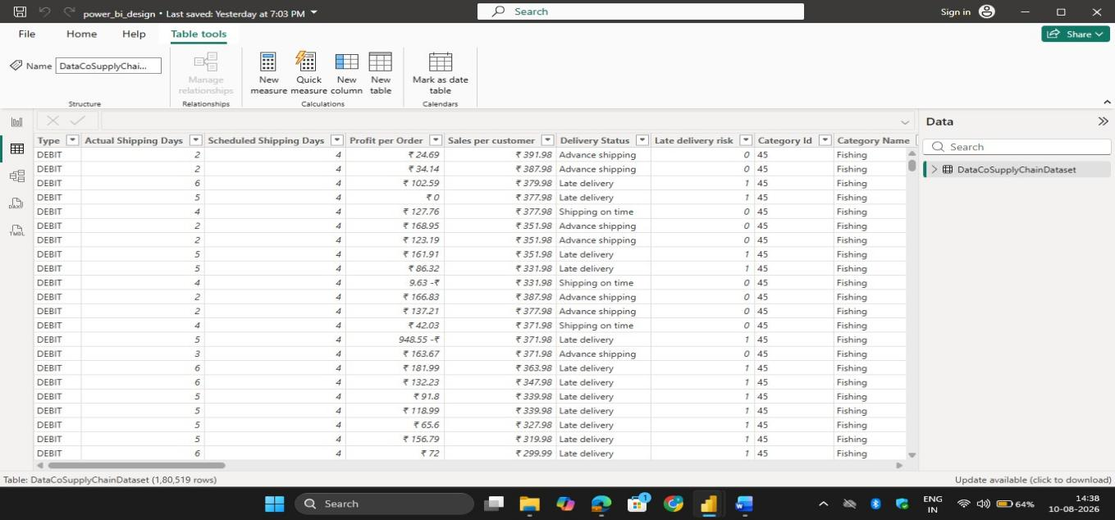
Fig.1 Preprocessing page 1

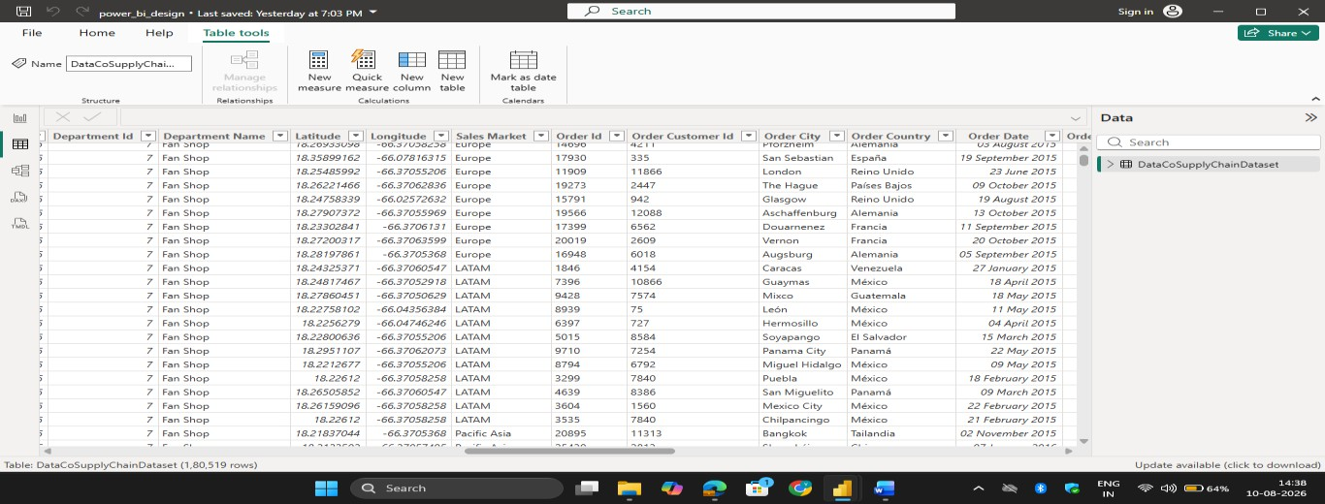
Fig. 2 Preprocessing page 2

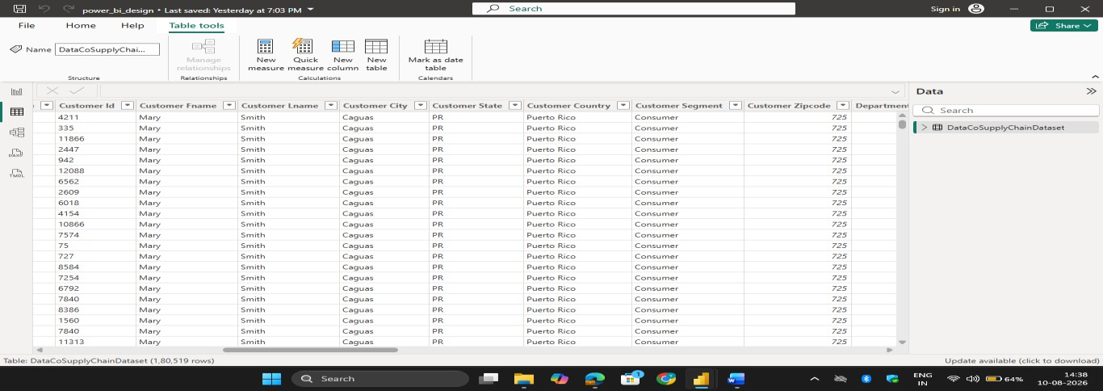
Fig. 3 Preprocessing page 3

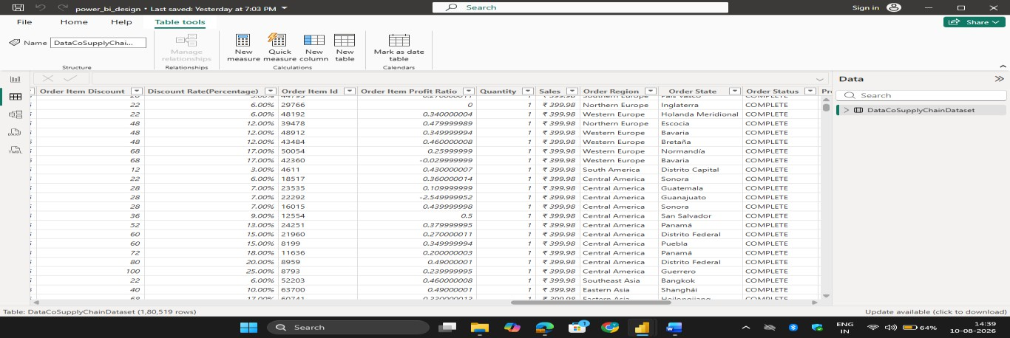

Fig. 4 Preprocessing page 4

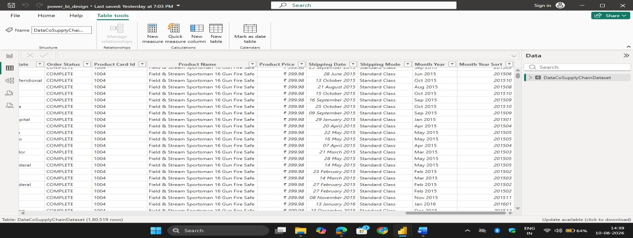
Fig. 5 Preprocessing page 5

Dashboard:
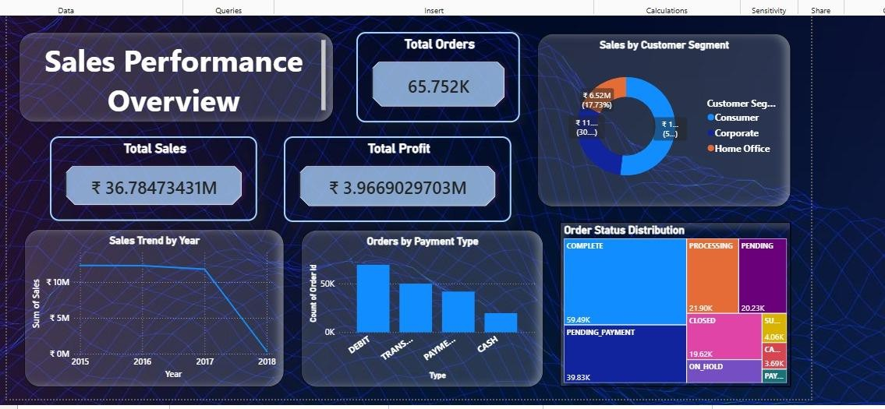
Fig 6 : SALES PERFORMANCE OVERVIEW

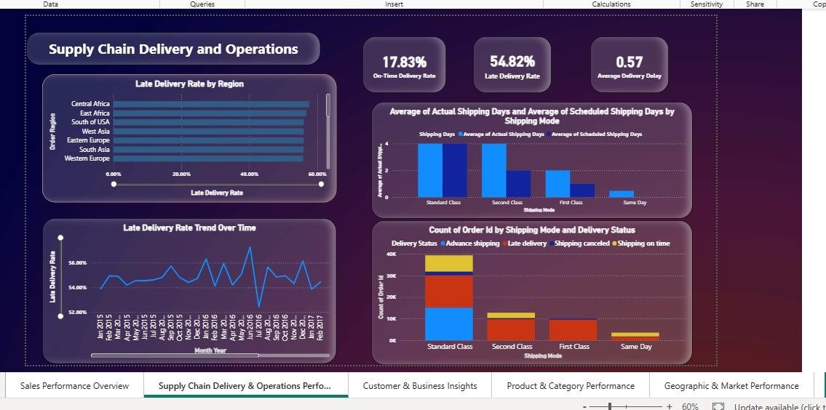

Fig 7 : SUPPLY CHAIN DELIVERY AND OPERATIONS

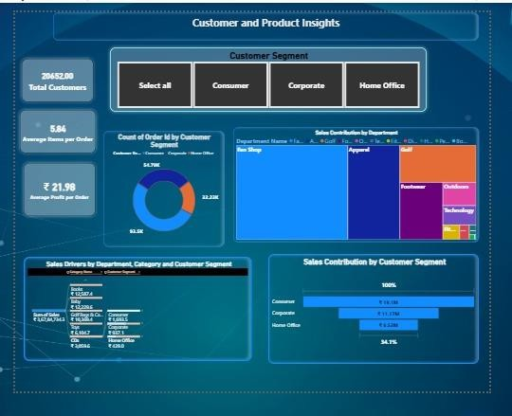

Fig 8 : CUSTOMER AND PRODUCT INSIGHTS

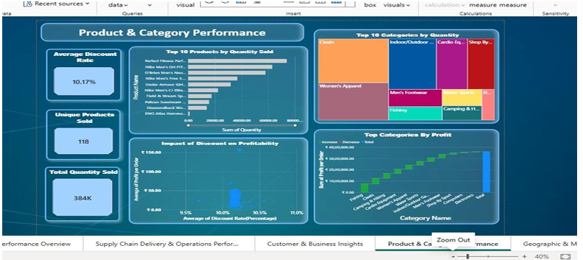

Fig 9 : PRODUCT AND CATEGORY PERFORMANCE

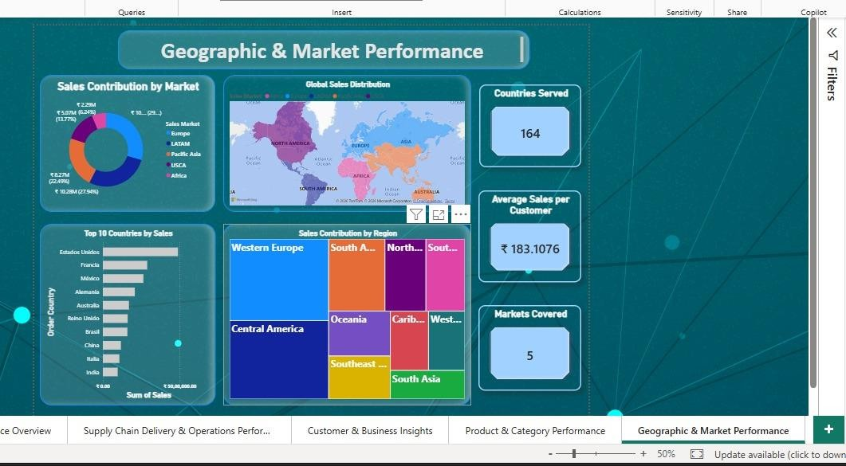

Fig 10 : GEOGRAPHIC & MARKET PERFORMANCE

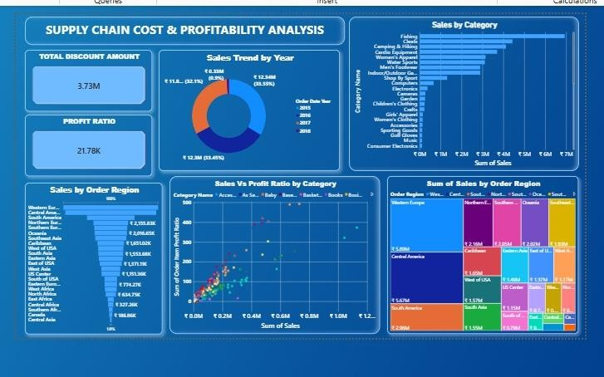

Fig 11 : SUPPLY CHAIN COST & PROFITABILITY ANALYSIS

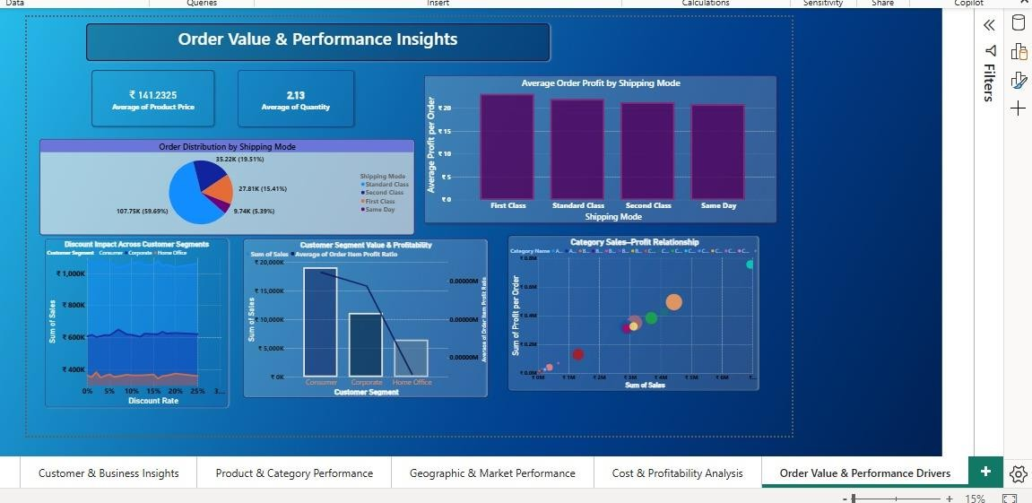
Fig 12 : ORDER VALUE & PERFORMANCE INSIGHTS

Challenges Faced
During the development of the Supply Chain Analytics Dashboard, several technical and analytical challenges were encountered. These challenges were addressed through systematic analysis, testing, and refinement.
- Understanding a Large Dataset
The DataCoSupplyChainDataset contains approximately 80,519 records and a large number of attributes. Initially, understanding the purpose and relevance of all the fields was challenging.
Resolution:
The fields were studied and grouped according to business areas such as orders, customers, products, sales, delivery, geography, and profitability. This made it easier to identify the appropriate fields for each dashboard page.
- Data Preparation and Transformation
Preparing the raw dataset for Power BI required checking different data types, date fields, numerical values, and other attributes. Incorrect or inconsistent data preparation could affect calculations and visualizations.
Resolution:
Power Query was used to review and transform the required fields before they were used for dashboard development. The prepared data was validated to improve the reliability of the analysis.

3.Creating Accurate KPIs and Measures

Developing KPIs such as Total Sales, Total Profit, Average Profit per Order, Delivery Rate, and Profit Ratio required appropriate calculations and aggregation methods.
Resolution:
DAX measures were created based on the analytical requirements, and the calculated results were reviewed against the dataset to ensure that the displayed values were meaningful.
- Selecting Suitable Visualizations
Another challenge was selecting appropriate visuals for different types of analysis while avoiding unnecessary repetition between dashboard pages.
Resolution:
Different visualization types were selected based on the purpose of the analysis. For example, line charts were used for trends, bar charts for comparisons, KPI cards for key metrics, scatter plots for relationships, and decomposition trees for detailed analysis.

- Dashboard Layout and Readability
Displaying multiple KPIs and visuals on the same page while maintaining a clean and professional appearance was challenging.
Resolution:
The dashboard was divided into six focused pages, with each page
covering a specific analytical area. Visuals were arranged
systematically to maintain readability and make important information easy to identify.
- Interpreting Dashboard Results
Converting numerical values and visual patterns into meaningful business insights required careful interpretation.
Resolution:
Each visualization was connected to a specific analytical purpose, such as identifying sales trends, delivery performance, customer contribution, top products, market performance, or profitability.
- Ensuring Consistency Across Pages
Since the dashboard contains six pages, maintaining consistent formatting, terminology, and presentation across all pages was another challenge.
Resolution:
A consistent design approach was followed for titles, KPI presentation, visual formatting, and page organization to provide a uniform user experience.
Overall Challenge Resolution
The challenges encountered during the project helped improve practical knowledge of Power BI, Power Query, DAX, data visualization, analytical thinking, and dashboard design. Solving these issues also improved problem-solving and decision-making skills during the development process.

Learnings & Skills Acquired

- The internship provided an excellent opportunity to apply theoretical knowledge to a real-world business problem through the development of a Supply Chain Analytics Dashboard using Microsoft Power BI. Throughout the project, I gained practical experience in data analytics, dashboard development, and business intelligence. Working with real-world supply chain data enhanced my understanding of data processing, visualization, and reporting while improving both my technical and professional competencies. The internship also helped me develop analytical thinking, teamwork, and communication skills that are essential for a successful career in data analytics.

Technical Skills
    - During the internship, I gained hands-on experience with Microsoft Power BI, which was the primary tool used for developing interactive dashboards and business reports. I learned how to import datasets, perform data transformation using Power Query, and prepare data for analysis by handling missing values, removing duplicate records, and correcting inconsistent data formats.
    - I also developed practical knowledge of Data Analysis Expressions (DAX) to create calculated measures, Key

Performance Indicators (KPIs), and custom metrics for business analysis. Additionally, I learned how to design user-friendly dashboards by selecting appropriate visualizations such as KPI cards, bar charts, line charts, scatter charts, treemaps, maps, and slicers. This experience improved my understanding of data modeling, report optimization, and dashboard interactivity, enabling me to present business insights in a clear and meaningful manner.

Analytical and Problem-Solving Skills
    - The internship significantly improved my analytical and problem-solving abilities by allowing me to work with a real-world pharmaceutical supply chain dataset. I learned how to examine large volumes of data, identify trends, compare business performance, and interpret results to support decision-making.
    - Throughout the project, I encountered several data-related challenges, including missing values, inconsistent records, and visualization selection. By systematically cleaning, validating, and analyzing the data, I was able to resolve these issues and generate accurate reports. This experience strengthened my ability to think logically, analyze business requirements, identify root causes of problems, and develop practical solutions using data-driven approaches.

Future Enhancements

    - Although the dashboard successfully provides valuable insights into supply chain operations, several enhancements can further improve its functionality and business value. One possible enhancement is the integration of real-time data sources, allowing organizations to monitor shipment activities and operational performance continuously.
    - The dashboard can also be extended by incorporating predictive analytics and AI-based forecasting to estimate future shipment demand, transportation costs, and inventory requirements. Additional features such as automated report refresh, drill-through reports, mobile-friendly dashboards, and advanced KPI monitoring can further enhance usability. These improvements would enable organizations to make faster, more accurate, and proactive business decisions while improving overall operational efficiency.

Soft Skills and Team Collaboration
    - In addition to technical knowledge, the internship helped me strengthen several important professional skills. Regular project discussions, presentations, and documentation improved my communication skills, enabling me to express ideas clearly and collaborate effectively with team members.
    - Working in a collaborative environment enhanced my teamwork and coordination skills. I actively participated in discussions, shared ideas, accepted constructive feedback, and supported team members whenever required. Taking
responsibility for assigned tasks also improved my leadership,
time management, adaptability, and organizational skills. These experiences taught me the importance of collaboration, accountability, and effective communication in successfully completing a project within the given timeline.

Domain Knowledge and Application
    - Supply Chain Management: Gained practical knowledge of supply chain operations by analyzing orders, sales, products, customers, shipping, delivery, and regional performance through the Power BI dashboard.
    - Sales and Business Analysis: Learned how sales, profit, order quantity, customer segments, and product categories can be analyzed to evaluate overall business performance and identify important trends.
    -  Delivery and Logistics: Developed an understanding of delivery performance by analyzing On-Time Delivery Rate, Late Delivery Rate, Average Delivery Delay, shipping modes, and delivery status.
    - Customer and Product Analysis: Learned how customer segments, product categories, quantity sold, discounts, and profit can be used to identify customer contribution and high-performing products.
    -  Business Intelligence Application: Applied domain knowledge by converting supply chain data into interactive dashboards and meaningful KPIs. The analysis demonstrates how Business Intelligence and data analytics can suppor.

TESTIMONIALS FROM TEAM

Venkata Puneeth Kothapalli
Mr. Venkata Puneeth Kothapalli played a significant role in the successful completion of this project. He provided continuous guidance and support throughout the project, especially during data preprocessing, data cleaning, transformation, and dashboard development. His technical knowledge and willingness to share ideas helped me overcome several challenges and improve the overall quality of the dashboard. I sincerely appreciate his support, collaboration, and encouragement throughout the internship.

Uppala Bhavya Sri
Ms. Uppala Bhavya Sri made valuable contributions to the project by actively participating in dashboard design, visualization development, and report preparation. She collaborated effectively with the team, shared useful suggestions, and helped in creating meaningful and interactive dashboards. Her teamwork and commitment greatly contributed to the successful completion of the project.

V. Charita Sree
Ms. V. Charita Sree joined the project at a later stage but quickly adapted to the project requirements. Despite joining late, she actively participated in the assigned tasks and contributed to the

successful completion of the project. Her cooperation, dedication, and willingness to support the team were highly appreciated.

Velpuri Sai Rohitha
Ms. Velpuri Sai Rohitha also joined the team during the later phase of the project and contributed positively to its completion. She supported the team in various project activities, coordinated effectively with other members, and completed her assigned responsibilities with commitment. Her contribution and teamwork played an important role in achieving the project objectives.

These testimonials reflect the valuable support and collaboration of my teammates throughout the internship. Their guidance, cooperation, and collective efforts helped create a productive learning environment and contributed significantly to the successful completion of the Supply Chain Analytics Dashboard project.

CONCLUSION :

The Supply Chain Visibility and Optimization Using Data Analytics project successfully transformed the DataCoSupplyChainDataset into an interactive and informative six-page Power BI dashboard. The project provides a structured view of different aspects of supply chain and business performance, including sales, orders, customers, products, delivery operations, geographic markets, costs, and profitability.
The dashboard presents important KPIs, trends, comparisons, and performance indicators through interactive visualizations. It helps users understand overall sales performance, customer contribution, product and category performance, delivery efficiency, market-wise sales, discounts, and profitability. Key findings such as the 17.83% On-Time Delivery Rate, 54.82% Late Delivery Rate, 20,652 customers, and ₹21.98 average profit per order provide useful insights into the current business and operational performance.
The project also demonstrates the importance of data preprocessing, data modeling, DAX calculations, and effective visualization in converting raw data into meaningful information. Using Power Query and DAX in Power BI helped prepare the data and create the required measures for accurate analysis.
Throughout the project, practical skills were developed in Microsoft Power BI, Power Query, DAX, data analytics, dashboard design, and business intelligence. The project also improved problem-

solving, analytical thinking, communication, teamwork, and presentation skills.
Overall, the developed dashboard provides better supply chain visibility and performance monitoring by bringing multiple business dimensions together in a single interactive platform. It can help users identify important trends, compare performance across different areas, recognize potential improvement areas, and support data-driven decision-making. The project demonstrates how Business Intelligence can be effectively used to transform large datasets into clear, actionable, and business-oriented insights.

ACKNOWLEDGEMENTS

We would like to express our sincere gratitude to the Infosys Springboard Team for organizing this highly enriching virtual internship program and for providing a structured, industry-aligned learning platform. The well-designed modules, milestone-based framework, and practical orientation of the internship enabled us to gain meaningful exposure to real-world business intelligence applications.
We extend our heartfelt appreciation to our mentor, Ms. Nityasree, for her consistent guidance, valuable feedback, and continuous encouragement throughout the project lifecycle. Her insights and structured direction played a significant role in shaping the analytical depth and professional quality of this project. We would also like to acknowledge our team members for their strong collaboration, accountability, and shared commitment toward achieving project objectives. The coordinated distribution of responsibilities, open communication, and collective problem-solving approach significantly contributed to the successful execution of this project. In addition, we extend our appreciation to the creators and maintainers of Microsoft Power BI documentation and community resources, which served as essential references during dashboard development and KPI implementation. We are also grateful to Kaggle for providing access to publicly available datasets that facilitated practical, hands-on analytical experience. The structured learning resources and practical exposure provided through this internship have significantly strengthened our

analytical thinking, technical proficiency, and business interpretation skills. This experience has enhanced our ability to approach data with a strategic mindset, collaborate effectively within a team environment, and execute projects with professional discipline. Overall, this internship has been a meaningful milestone in our academic and professional journey, reinforcing the value of data-driven decision-making and structured analytical execution in modern business environments.

